**Assignment 1 – Set up Linux OS on VM**

Prerequisites

* A computer ( Windows 10 or Later ) with internet access
* Demonstrate your work to your lab professor during your lab session for grading.
* Download Document Assignment 1.
* This document will have instructions and designated areas where you’ll need to insert **screenshots** of your work. Complete your document with Screenshots and show to the lab professor for grading.
* Due Date: Start of next lab.

# Part 1: Create a Red Hat account

Go to the Red Hat Developer website: <https://developers.redhat.com/products/rhel/overview>

In the top-right corner, click **Log In**.

* You don't have a Red Hat login yet, so click **Register for a Red Hat account** at the bottom of the box.

1. On the Register for a Red Hat account page, fill out the form.
2. Where it says, "Choose a Red Hat login", type your Algonquin student email address.
3. Choose a password.   
   Note: don't forget your password because you will need it later in this lab.
4. In the **Job role** field, select "Student".
5. Select the checkboxes beside "I have read and agree to all the terms and conditions..."
6. Click **Create my account**.

Here's a screenshot of what that will look like:

After you click **Create my account**, you will see this screen.

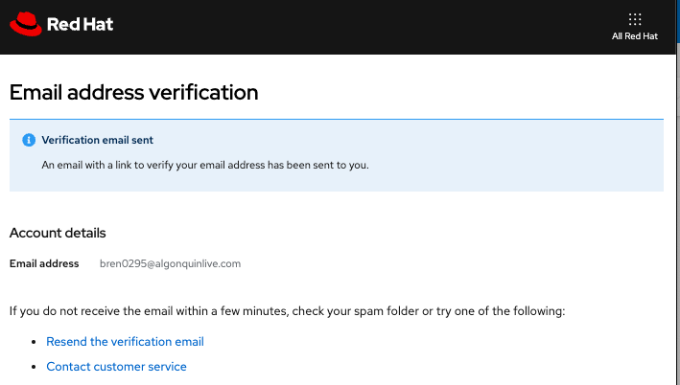

In a few minutes, check your Algonquin student email for an email titled "Verify email for Red Hat account". Click the link that says, "Link to e-mail address verification".

Clicking the link will take you back to the Red Hat website:

Click **Finish**.

## Troubleshooting

If you do not receive the email to verify your Red Hat account within a few minutes:

1. check your spam folder

2. resend the verification email

3. [Contact Red Hat customer service](https://access.redhat.com/support/contact/customerService/)

If you forget what your Red Hat login is, go to <https://developers.redhat.com/> and click the icon in the top-right corner (assuming that you are still logged in).

If you forget your password, you can reset it using the "Forgot your password?" link on the login page.

# Part 2: Download a Red Hat Linux ISO file

In your web browser, navigate to <https://developers.redhat.com/products/rhel/overview>.

Click the **Download RHEL at no-cost** button.

The file will start downloading (probably to your Downloads folder). It might take a while because the file is large.

Congratulations! You have downloaded the Linux ISO file. Don't try to run it. You'll use it later. Let's move on to the next task.

# Part 3: Download VMware Workstation Pro

Note: You might already have VMware Workstation Pro installed on your computer because you're using it in another class. If that's the case, just use that. Don't install it twice.

Follow the link to download the VMware workstation software.

[VMware-workstation-full-17.6.2-24409262.exe](https://algonquinlivecom-my.sharepoint.com/:u:/g/personal/sidhug_algonquincollege_com/EZAaTuiZIK5Dh0wVueROTCQBGWSJp7QAUX3etgNJ8mvWPw?e=4b1SpC)

Using the Windows file browser, go to the directory where you downloaded the file (probably your Downloads folder).

Double-click the VMware workstation file. The installer will run.

It will ask you “Do you want to allow this app to make changes to your device?”. Click **Yes**.

Click **Next**.

Select the checkbox beside, “I accept the terms in the License Agreement” and click **Next**.

Click **Next**.

Click **Next**.

Click **Next**.

Click **Install**.

After the installation finishes, you will see this:

Click **Finish**.

Note: You do not need to enter a license key anymore.

To launch VMware Workstation Pro click the VMware Workstation Pro icon on your desktop or go to the Start menu and select VMware Workstation Pro from the list.

Select the radio button beside “Use VMware Workstation 17 for Personal Use” and click **Continue**.

Click **Finish**.

# Part 4: Create a New Virtual Machine

Click **File** > **New Virtual Machine**.

Select **Custom (advanced)**.

Click **Next**.

Click **Next**.

Select “I will install the operating system later.”

Click **Next**.

Select **Linux**.

In the Version dropdown menu, select **Red Hat Enterprise Linux 9 64-bit**.

Click **Next**.

Type a name for your virtual machine, such as: RHEL_CST8207.

**\*\*\* In the Location field, choose a location that is not in the cloud or on OneDrive because that would be very slow. Also, make sure your location is unique because you don’t want to put your VM into the same directory as another VM.**

For example, I set the location to:  
 C:\Users\Student\Documents\Virtual Machines\RHEL_CST8207

Click **Next**.

Make sure “Number of processors” is set to 2.

Change memory to 4096.

Click **Next**.

Choose **NAT**.

Click **Next**.

Choose **LSI Logic (Recommended)**

Click **Next**

Select **NVMe**

Click **Next**.

Select **Create a new virtual disk**.

Click **Next**.

Set the maximum disk size to 20.

Select **Split virtual disk into multiple files**.

Click **Next**.

Leave the default disk file name.

Click **Next**.

Click **Finish**.

You now have a virtual machine with the name you created in the previous steps.

# Part 5: Install the Red Hat Enterprise Linux Operating System

Click **Edit virtual machine settings**.

Click **CD/DVD (SATA)**.

Select **Connect at power on**.

Select **Use ISO image file**.

Browse to the place where you downloaded the ISO file earlier, select it and click **Open**.

Power on the virtual machine.

Click on the virtual machine screen.

Select **Install Red Hat Enterprise Linux 9.4**.

You will see a black screen. Be patient. It will take a few minutes to start installing.

When it starts installing, it will look like this:

Eventually you will see this screen:

Select **English** and **English (Canada)**.

Click **Continue**.

Click **Installation Destination**.

In the Local Standard Disks section, make sure the 20 GiB disk has a black checkmark.

Click **Done**.

In the User Settings section, click **Root Password**.

Set the Root Password. Write it down for future reference.

Click **Done**.

In the User Settings section, click **User Creation**.  
** use your full name  
** for username :- use your Algonquin college username  
** set the password (*Make sure to Write it down for future reference)

Click **Done**.

Click **Connect to Red Hat**.

Use the same credentials you used to register yourself for Red Hat in Part 1.

Click the **Register** button.

Click **Done**.

Click **Done**.

Click **Network & Host Name**.

Make sure Ethernet is on. You can turn it on by toggling the button on the right-hand side.

Click **Done**.

Click **Software Selection**.

Select the following:

* Server with GUI
* Mail Server
* Remote Management for Linux
* Security Tools
* System Tools

Note: You might need to scroll through the list in the right-hand pane to see all the items.

Click **Done**.

Click **Begin Installation**.

It will take time to complete the installation.

After the installation completes, click **Reboot System**.

The screen will turn black for a few minutes.

After the system restarts, click on the name and enter your password (not the root password).

Click Activities in the top-left corner.

Click on the Terminal icon.

You will see a screen like this:

At the prompt, type the command “mkdir” which makes a directory and specify the directory name to be the same as your Algonquin student ID number. For example:

$ mkdir abcd1234

Next, type the command “ls” (small letter L, not the number “1”), which lists all the files in a directory:

$ ls

Take a screenshot of your terminal screen and save it. You can use the Windows Snipping Tool to take the screenshot or any other software that you like.

Screen shot : Example

To demo your lab work, show your terminal window to your lab professor.

To shut down your virtual machine, click the power button in the top-right corner and then click **Power Off / Log Out**.

## Troubleshooting

Problem: The machine freezes when setting up Linux in the part where you are setting the language.

Resolution:

1. Edit the virtual machine settings.
2. Click Display.
3. Clear the checkbox beside Accelerated 3D graphics.

Problem: Message “VMware Workstation cannot connect to the virtual machine. Make sure you have rights to run the program, access all directories the program uses, and access all directories for temporary files. Faile to connect pipe to virtual machine: All pipe instances are busy.”

Resolution:

1. Go into the directory where your VM files are stored and delete any .vmem or .lck files.
2. Do a full shutdown of windows. At the Windows command prompt in administrator mode type the command: shutdown /s /f /t 0  
   Note: This will shutdown Windows immediately so make sure you have saved any work.
3. Start the virtual machine.

Problem: Network is not connected.

Resolutions:

Toggle the network type from NAT to Bridged and then back to NAT.

If you have another virtual machine running that is using an internet connection, shut it down so that only one virtual machine is running. Some ports only support 2 concurrent connections.

Check if the internet connection is working on the host machine (Windows).

Problem: Error message about monitor mode Intel VT-x

Resolution: Modify the setting in the Windows BIOS. Press F2 at Windows startup.

Problem: Error message says that the Red Hat virtual machine has already been registered.

Resolution: Contact Red Hat technical support.

Problem: When the virtual machine starts up, it doesn’t show the GUI but instead, shows a text login prompt “Activate the web console…” and displays “localhost login:”

Problem: Slowness

Resolution: Make sure VM files are not stored in the cloud or on OneDrive. They should be saved on your local hard drive.